2 October 2018

NOTICE OF GENERAL MEETING EVRAZ HIGHVELD STEEL AND VANADIUM LIMITED
Registration Number 1960/001900/06

The Business Rescue Practitioners hereby inform you that the general meeting scheduled for 10 October 2018 is hereby cancelled, due to there being no material changes from the previous meeting and all matters are proceeding in accordance with the business rescue plan.

A further meeting will be scheduled in the event of there being any significant change or announcement in respect of Highveld, which is expected to take place before the end of the year.

The monthly report will, as usual, contain all details and updates in respect of operations currently being undertaken.

Any queries in respect of the above or related to the business rescue, may be directed to evrazhighveld@matusonassociates.co.za.

Yours faithfully
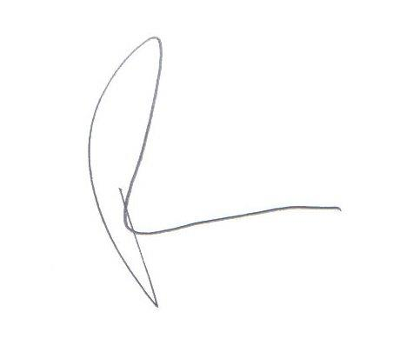
_______________________________
PIERS MARSDEN
JOINT BUSINESS RESCUE PRACTITIONER

